Pls contact us :35007117@ qq.com
-----------------------------------------------------------------------------
Button module
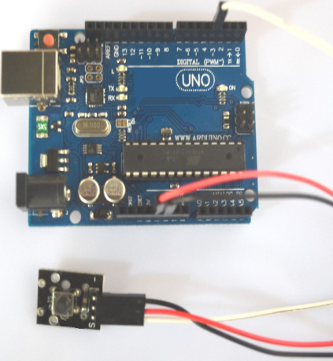

Button module can connect UNO R3 PIN13, make button test.
Pin 13’s LED，use button module connect Pin 3. When button module test there is button single, led can be bright.

Code

int Led=13;//Define LED interface
int buttonpin=3 //Define key switch sensor interface
int val;//Define numeric variable val
void setup()
{
pinMode(Led,OUTPUT);//Define LED as output interface
pinMode(buttonpin,INPUT);//Define key switch sensor as output interface
}
void loop()
{
val=digitalRead(buttonpin);//Read the value of the value of the digital interface 3 to val
if(val==HIGH)//When the key switch sensor detects the signal, LED flashes
{
digitalWrite(Led,HIGH)
}
else
{
digitalWrite(Led,LOW)
}
}

